**Capstone Groupings**

**Team 1**

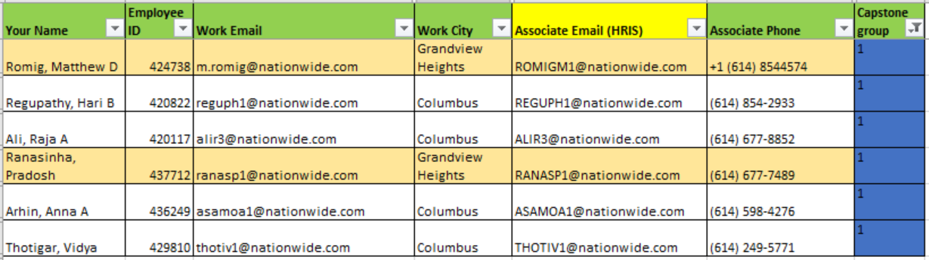

**Team 2**

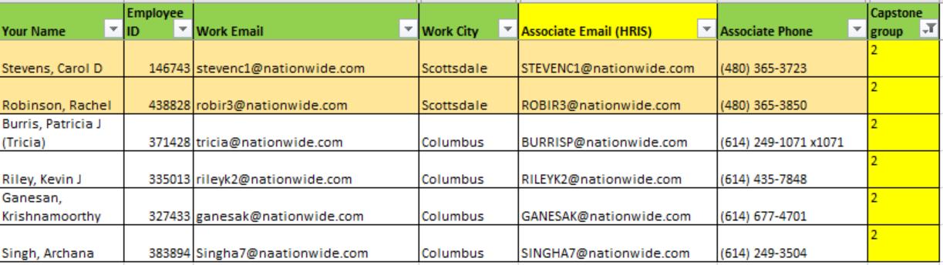

**Team 3**

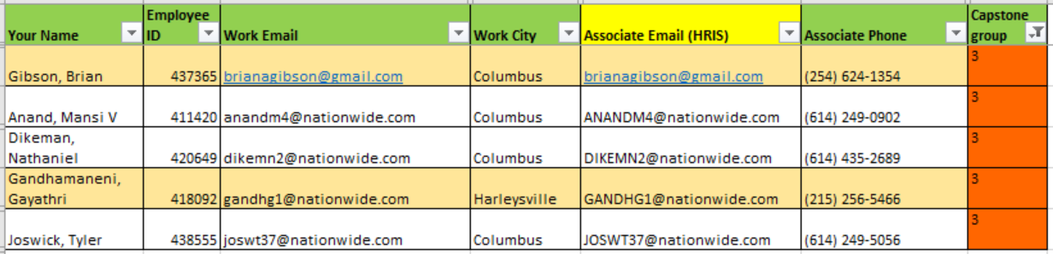

**Team 4**

